 | Trainer Pool Management  Technical Design Document  1.0
 | Prepared By / Last Updated By | Reviewed By | Approved By
Name | Gauresh | Udit | Mr. Vinay Agnihotri
Role | Team Member | Team Member | Scrum Master
Signature | Gauresh | Udit
Date | 24th-apr-2019 | 24th-apr-2019 | 24th-apr-2019

Table of Contents

1.0 Introduction 3
1.1 Purpose of this document 3
1.2 Scope 3
1.3 Intended Audience 3
1.4 Definition & Acronyms 3
2.0 Conventions and Standards Followed 4
3.0 Assumptions, Dependencies and Risks 4
3.1 Assumptions: 4
3.2 Dependencies: 4
4.0 Schematic Diagram 4
5.0 Use Case Realization 5
5.1.1 User Registration 5
a. Functional Requirement 6
b. UI Validations 6
c. UI Controls 7
d. UI Methods Definition 8
e. UI Design 9
6.0 Database Design 10
6.1 Data Model 10
6.2 Tables Structure 10
7.0 Change Log 13

Introduction

Purpose of this document
The purpose of the detail design document is to define the detailed design for all the components of Patient Health Management system that are specified in the Business Requirement/Use case document. All the low level components, interfaces and integrations are detailed out in this document.

Scope
This sub-section shall state the scope of this detailed design document
• Create and maintain Trainer information.
• Create and maintain SME information

Intended Audience
The intended audience for this document are
- Developers, testers, other associates in the project
- Technical lead, Scrum Master
- Product Owner

Conventions and Standards Followed
The modules under scope needs to adhere to the coding standards and guidelines


Assumptions, Dependencies and Risks

Assumptions:
- Once the application is built the Trainer Pool Management System will Systematically load the Trainer list into the system after going through registration
- There will be no concurrent users for the application. The Trainer profile will be maintained by the Administrator.

Dependencies:
- Availability of database design characteristics & access shall be defined by the
- Resource availability throughout each of the sprint

Use Case Realization

Trainer Registration

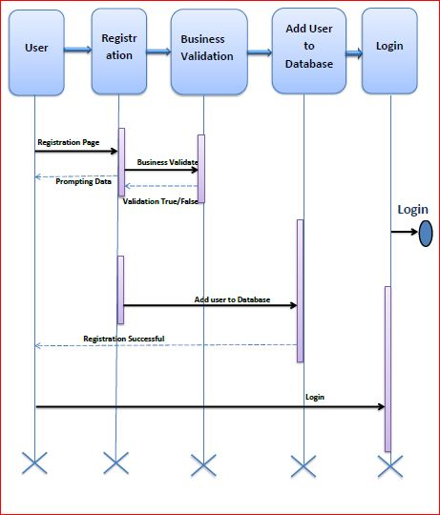

Functional Requirement
. Login Page checks the authentication of the user and based on his role, directs the user to the respective page. User will provided with Add Patient, Details, Regulation and Search regulation pages and the same user will allowed to see Diagnosis Reports and patient vital parameters reports

UI Validations
- User Id and Password fields are mandatory.
- Invalid User Id and / or password should not allow the user to get into the system

UI Controls
# | UI Component | Type | Name | Details
1 | User Id | Label | label_For_User_Id
2 | User | Text field | Textfield_user | To enter username
3 | password | Label | Label_for_password
4 | password | Text field | Textfield_password | To enter password

Database Design

Tables Structure
Trainer/SME Registration:
Column Name | Data Type | Length | Nulls
Employee_Id | number | 6 | N
First _Name | Varchar2 | 30 | NN
Middle_Name | Varchar2 | 30 | NN
Last_Name | Varchar2 | 30 | NN
D_O_B | Varchar2 | 15 | NN
Gender | Varchar2 | 8 | NN
Contact_Number | Varchar2 | 10 | NN
Role_name | Varchar2 | 20 | NN
Email | Varchar2 | 30 | NN
Username | Varchar2 | 50 | N
Password | Varchar2 | 50 | N
Skill1 | Varchar2 | 50 | N
Martial_Status | Varchar2 | 10 | N
Permanent_address | Varchar2 | 80 | N
Residential_address | Varchar2 | 80 | N
Pan_Number | Varchar2 | 10 | N
Qualification | Varchar2 | 25 | N
Certification | Varchar2 | 25 | N
Certificate_Description | Varchar2 | 25 | N
Organization | Varchar2 | 30 | N
Skill_2 | Varchar2 | 20 | N
Skill_3 | Varchar2 | 20 | N

Trainer/SME login:
Column Name | Data Type | Length | Nulls
User Id | nvarchar | 50 | N
Password | nvarchar | 50 | N

Skills:

Field Name | Field Type | Data Type | Mandatory | Possible Values
Skill_Id | Numeric | Integer | Yes | Not Null Unique
Skill_Name | Text (30) | Varchar | Yes | Primary Key

Login Info

Field Name | Field Type | Data Type | Mandatory | Possible Values
username | Text (30) | Varchar | Yes | Foreign Key
password | Text (30) | Varchar | Yes | Not Null
Role_name | Text (30) | Varchar | Yes | Not Null

Mapping

Field Name | Field Type | Data Type | Mandatory | Possible Values
Employee_Id | Numeric (6) | Integer | Yes | Foreign Key
Skill | Text (15) | Varchar | Yes | Not Null
From_Date | Date | Date | Yes
To_Date | Date | Date | Yes
Location | Text (15) | Varchar | Yes | Not Null
Rating | Numeric (5) | Integer | Yes

Leave Table

Field Name | Field Type | Data Type | Mandatory | Possible Values
Employee_Id | Numeric (6) | Integer | Yes | Foreign Key
From_Date | Date | Date | Yes
To_Date | Date | Date | Yes
Reason | Text (50) | Varchar | Yes

Change Log
Please note that this table needs to be maintained even if a Configuration Management tool is used.
Version Number | Changes made
V1.0 | <First version>
V1.1 | <If the change details are not explicitly documented in the table below, reference should be provided here>
V1.1 | Page no | Changed by | Effective date | Changes effected
V1.2 | <If the change details are not explicitly documented in the table below, reference should be provided here>
V1.2 | Page no | Changed by | Effective date | Changes effected

